**Web Dev Report**

**Sean Daly – C15448362 Restaurant**

**HTML**

In total there is 11 HTML files which output the necessary photos and tables which are on the webpages. They use various CSS style sheets and are functional through JavaScript.

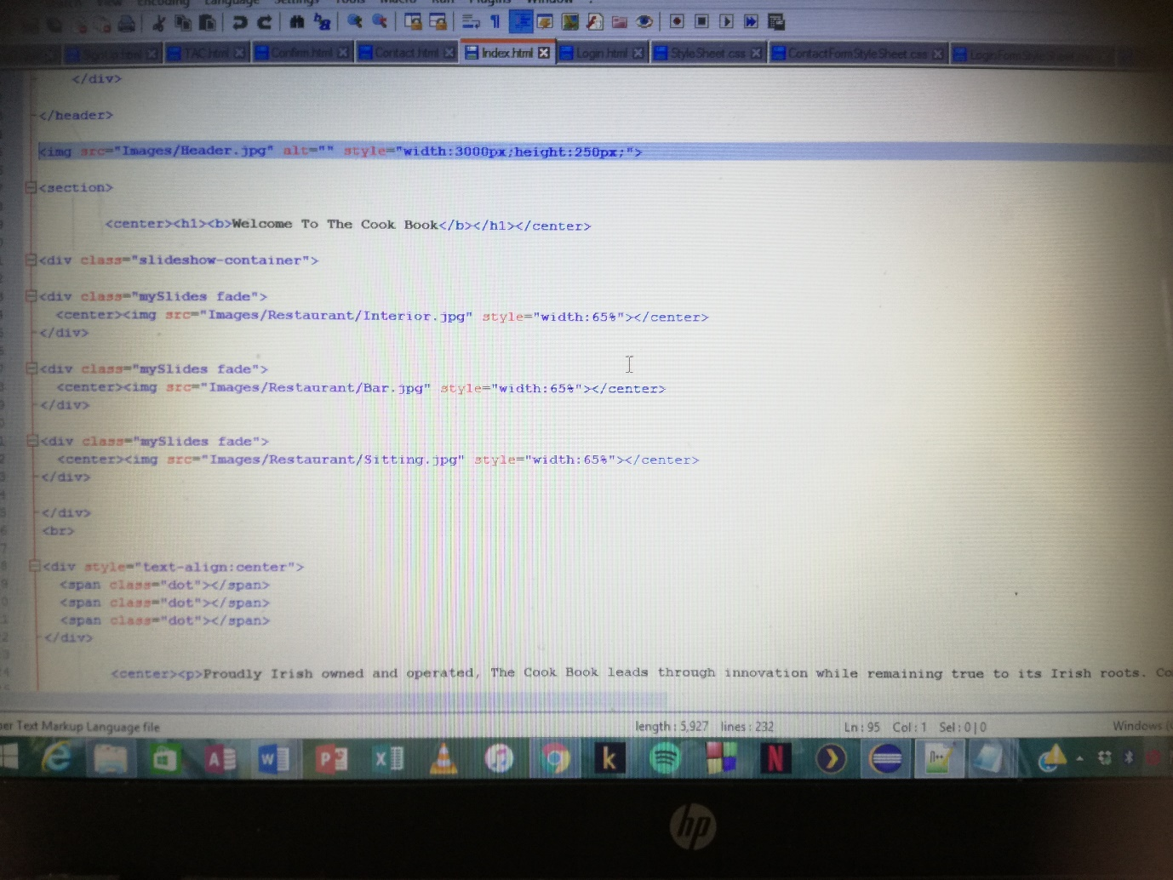

**CSS**

There is 5 Stylesheets which run the design of the website and the placement of the photos and tables on the website.

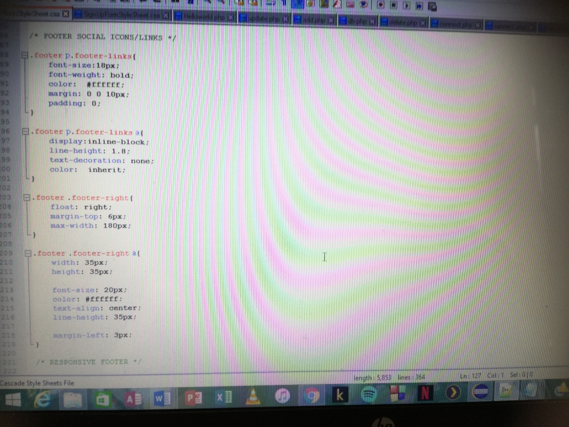

**JavaScript**

There is 7 JavaScript files which run the functionality of the website. They run such things as addition of value of food,orders and log in.

